CYBERSECURITY INTERNSHIP
Organization name:- Elevate labs

Student Name:- Kemisetti Bhima Sai Sundar
University:- Aditya University
Domain:- Cybersecurity
Duration:- 1st January 2026 to 30th April 2026

TASK-2: Operating System Security Fundamentals (Linux & Windows)

Operating system:
An operating system (OS) is the core software that acts as a bridge between the user and the computer hardware. It manages all the essential resources of a computer such as the processor, memory, storage, and input/output devices, ensuring that different programs run smoothly without interfering with each other. Whenever a user opens an application, saves a file, or connects to the internet, the operating system is working silently in the background to make these actions possible. Popular operating systems like Windows, Linux, and macOS provide user-friendly interfaces while also handling complex tasks such as process scheduling, file management, and security enforcement.

Virtual Machine:
A virtual machine (VM) is a software-based imitation of a physical computer that allows multiple operating systems to run independently on the same hardware. Instead of installing an operating system directly on a physical machine, a VM creates a virtual environment with its own virtual CPU, memory, storage, and network interface. This makes it possible to run different operating systems side by side without affecting the main system. Virtual machines are widely used in cybersecurity, software testing, cloud computing, and server environments because they provide isolation, flexibility, and efficient resource utilization. If something goes wrong inside a virtual machine, it does not usually impact the host system, making VMs a safe and reliable option for experimentation and learning.

Virtual Box:
VirtualBox is a popular open-source virtualization software developed by Oracle that allows users to create and manage virtual machines on their computers. It works as a platform where different operating systems such as Linux, Windows, or even older versions of operating systems can be installed and run as guest systems. VirtualBox is especially useful for students, developers, and cybersecurity professionals because it supports features like snapshots, shared folders, and network configuration modes. These features allow users to test software, practice security labs, or explore new operating systems without risking damage to their main system. Its simple interface and free availability make VirtualBox an ideal choice for beginners learning virtualization concepts.

Linux:
Linux is a powerful, open-source command line operating system known for its stability, security, and flexibility. Unlike proprietary operating systems, Linux allows users to view, modify, and distribute its source code, which has led to the creation of many different distributions such as Ubuntu, Kali Linux, Fedora, and CentOS. Linux is widely used in servers, cloud platforms, embedded systems, and cybersecurity environments due to its strong permission model and extensive command-line capabilities. For learners and professionals, Linux offers a deeper understanding of how operating systems work internally, making it an essential skill in fields like networking, ethical hacking, and system administration. Overall, Linux represents freedom, control, and reliability in the world of operating systems.

The Linux that was used in this task is Kali Linux. Kali Linux is a specialized Linux distribution designed specifically for cybersecurity professionals, ethical hackers, and digital forensics experts. It is based on Debian and is developed and maintained by Offensive Security, with a strong focus on security testing and penetration testing.
- Installation of Kali Linux using virtual box:
Installing a Kali Linux virtual machine (VM) using tools like VirtualBox is one of the safest and most practical ways to learn operating system security. A VM allows us to run Linux as a separate system inside our main computer without affecting the host OS. This isolated environment is ideal for experimenting with security settings, permissions, and system configurations.
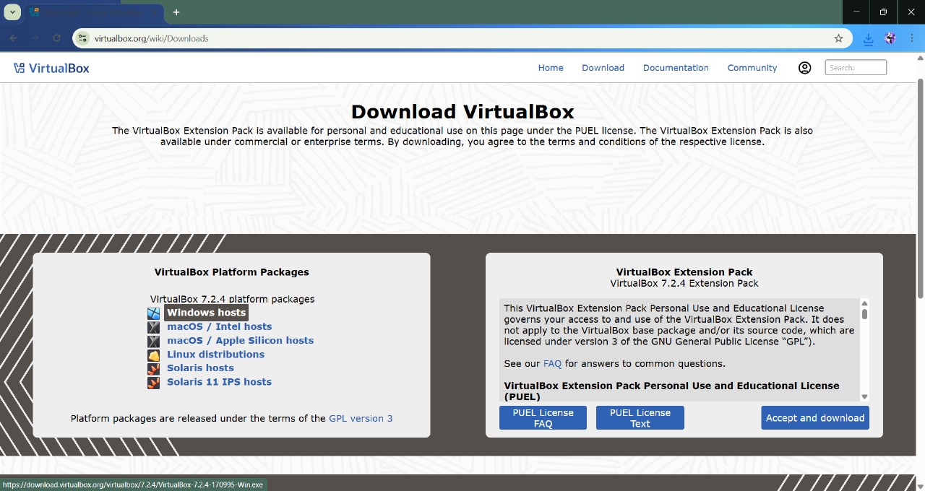

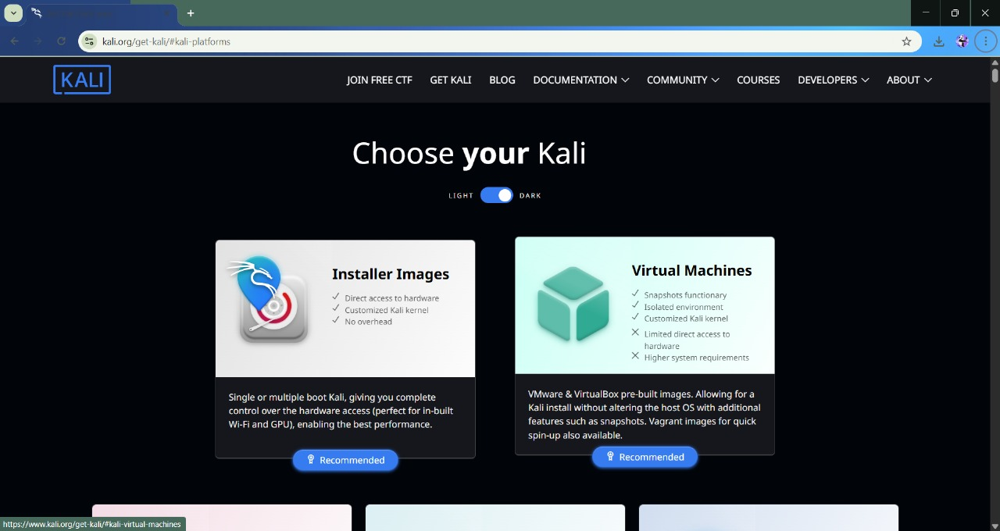

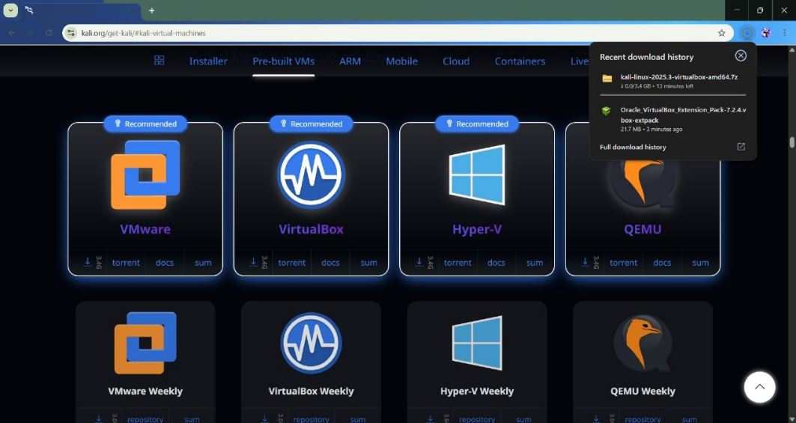

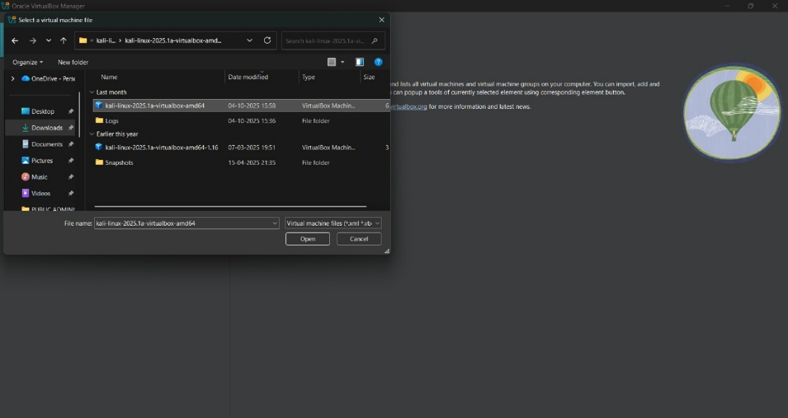

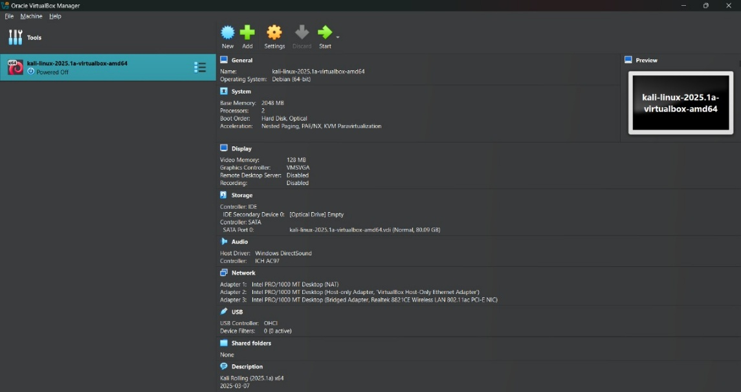

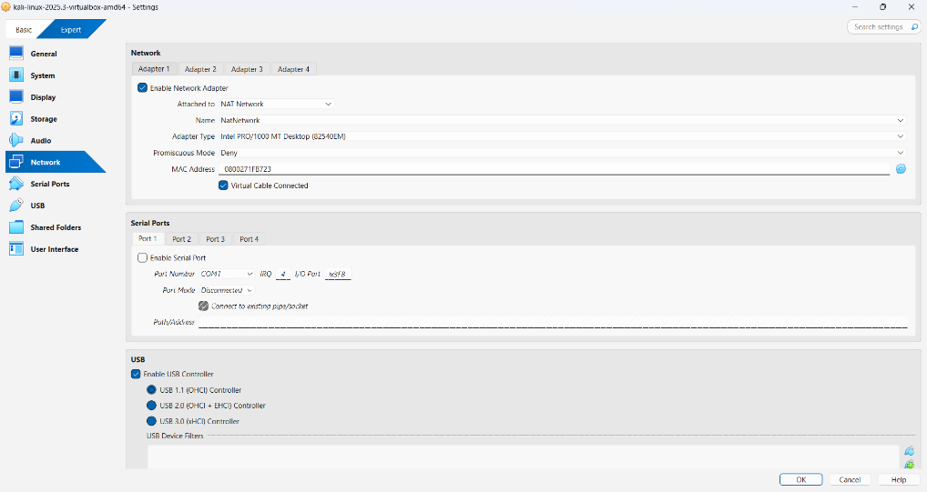

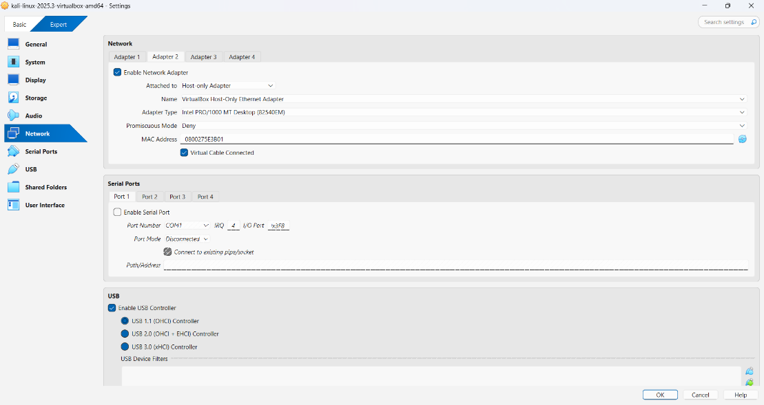

A secure Linux environment is created where OS security concepts can be practiced safely without risking the host system.

- Exploring user accounts, permissions, and access control mechanisms:
In Linux, every person who uses the system is treated as a user. Each user has a specific identity and limited access. This is important because not everyone should be allowed to access or modify system files. Linux follows the concept of access control, where permissions decide who can do what on the system. This prevents unauthorized access and accidental damage.
Linux mainly has:
Root user – full control over the system
Normal users – limited access for daily work

There are some commands in Linux to see the users, current directory, to create a new user etc.
- To check the user:
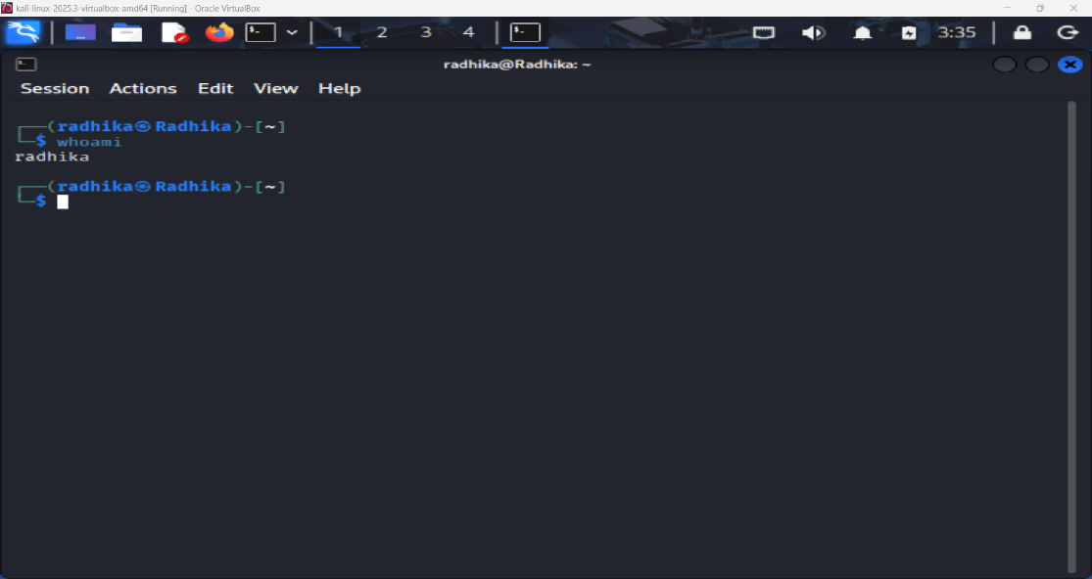
Whoami

- View all users present in the system:
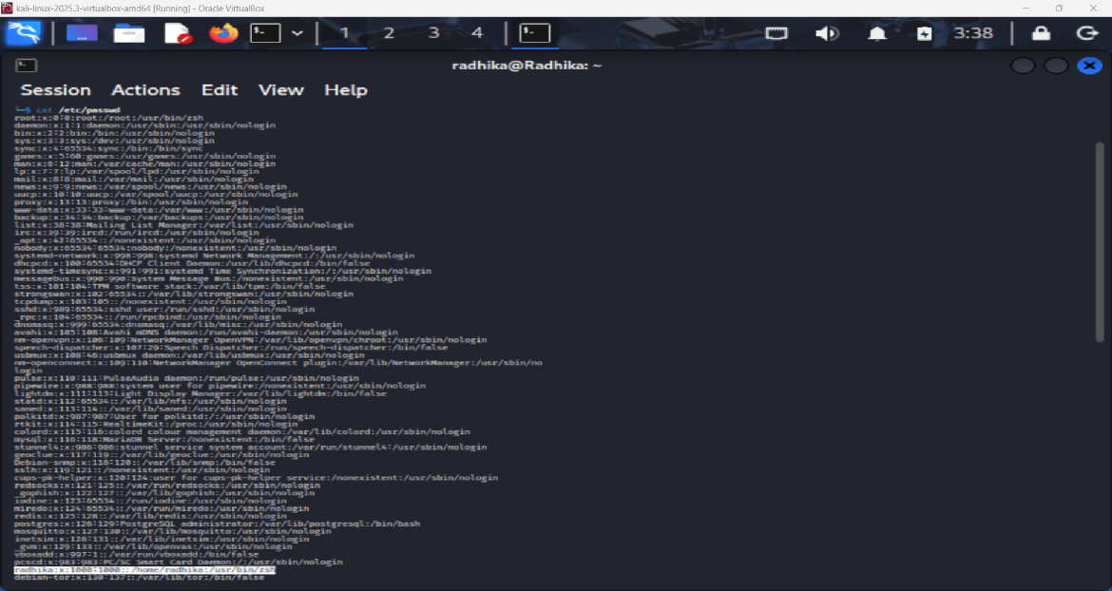
cat /etc/passwd
only one user is present as of now.
- To get root access:
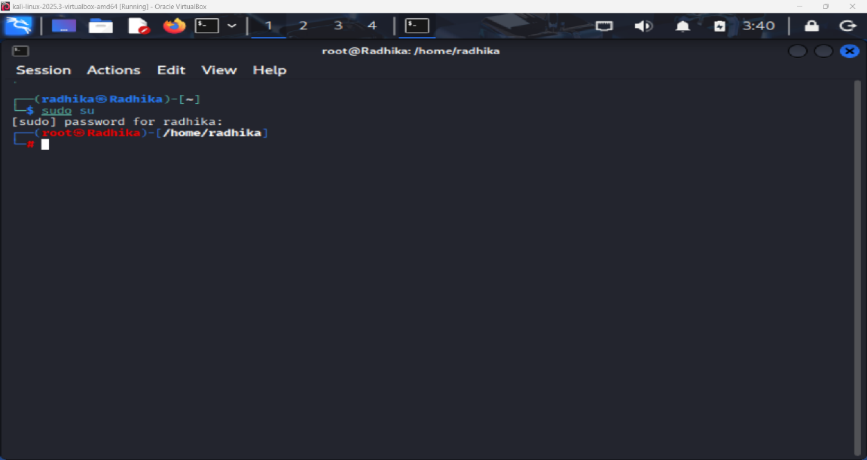
Sudo su
- Try accessing an admin-level command (permission check):
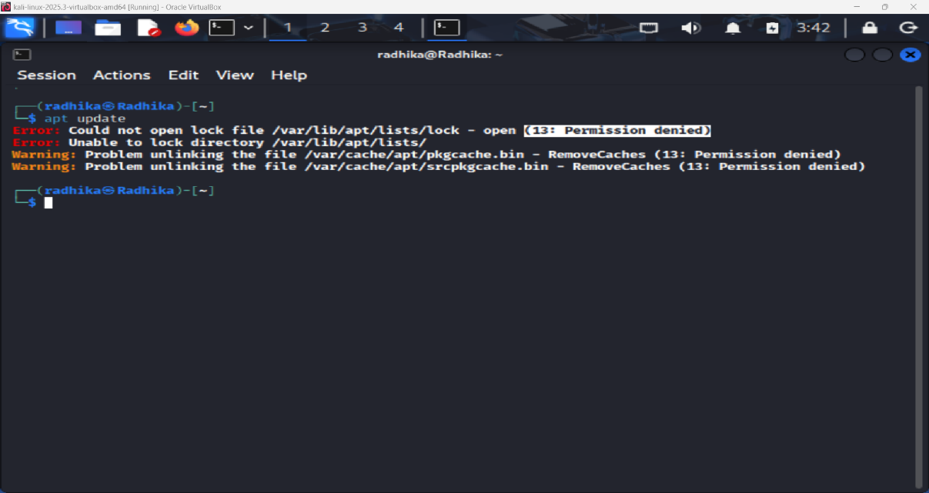
apt update
permission denied as there is no high-level access (root access).
To get that permission, you need to run command – sudo apt update.

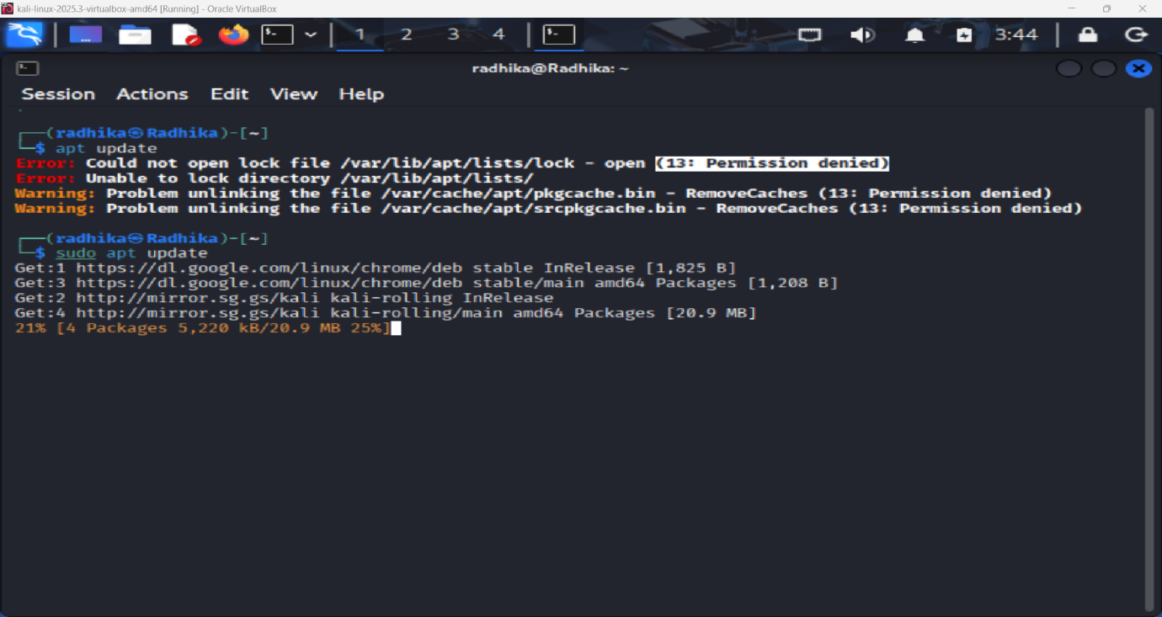
As it got high-level access, it got permission to update the system.

- Learning file permissions using chmod, chown, and ls -l:
In Linux, every file and folder has permissions that decide:
- Who can read the file
- Who can write/edit the file
- Who can execute/run the file

Permissions are divided into:
- Owner
- Group
- Others

The permissions are represented as:
- r – read
- w – write
- x – execute

- To check the permissions for a text file:
Ls -l text file name .txt
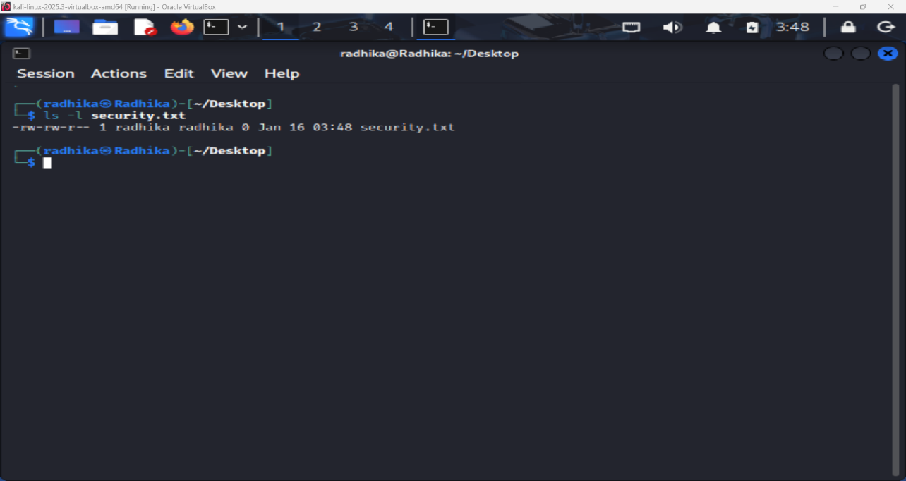
rw- → owner can read & write
r-- → group can only read
r-- → others can only read

- Change file permissions using chmod:
Chmod 700 text file name.txt
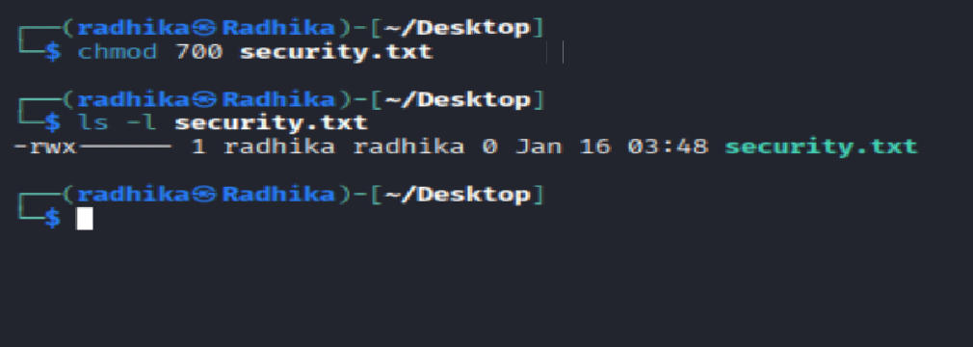

Initially, it has access to groups and others to read. But now that access permission is denied using chmod.
- Change file ownership using chown:
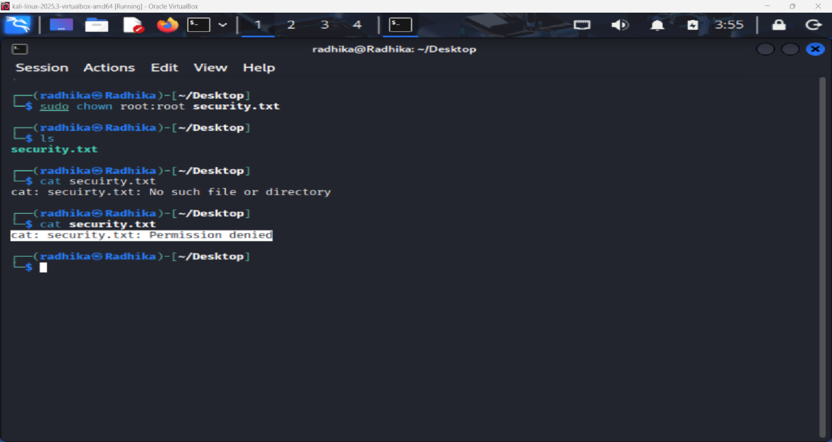
sudo chown root:root text file name.txt

This allows the file to be accessed by the high-user who is privileged to access it. It is opened only when there is root access unless the permission is denied.
- Restore permissions:
sudo chmod 644 text file name.txt

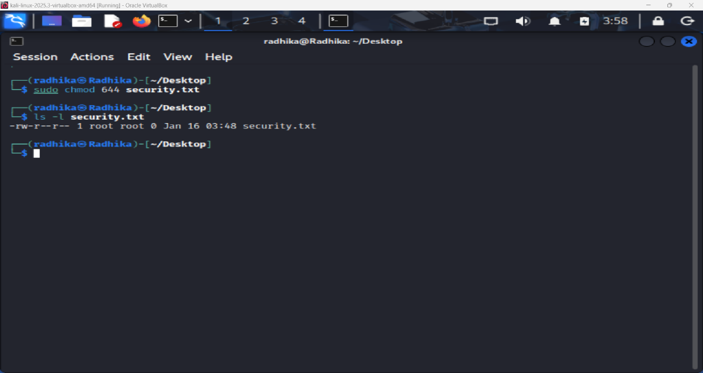

The permissions are revoked to normal.
- Understand administrator vs standard user privileges:
Understanding the difference between administrator (root) and standard user privileges is essential for secure system management. The administrator has complete control over the system, including installing software, modifying system files, and managing users. In contrast, standard users have limited permissions, which restrict them from making critical changes. This separation minimizes risk because even if a standard user account is compromised, the attacker cannot easily take full control of the system. Hence, daily activities should always be performed using a standard account rather than an administrator account.

- Enable firewall:
A firewall acts as the first line of defense between a system and the outside network. Enabling UFW (Uncomplicated Firewall) in Linux or Windows Firewall in Windows helps monitor and control incoming and outgoing network traffic based on predefined security rules. Firewalls prevent unauthorized access, block suspicious connections, and protect the system from network-based attacks. By configuring a firewall properly, users can significantly reduce the chances of intrusion while still allowing necessary services to function smoothly.
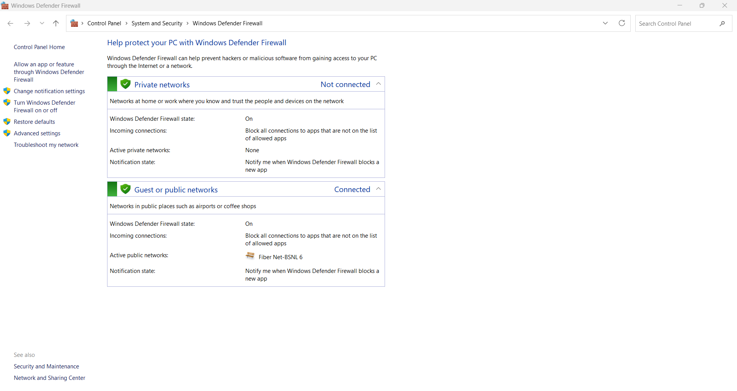

By going to settings, click on windows defender firewall. Then turn on the enable firewall option (windows operating system firewall enabling).
- Identify running processes and services:
Running processes and services represent active programs and background tasks operating within the system. By identifying these processes using commands like ps, top, or system monitoring tools, administrators gain visibility into what is currently running. This awareness helps detect unusual or malicious activity, such as unknown processes consuming high resources. Understanding system processes also enables better performance management and helps ensure that only trusted applications are allowed to operate.
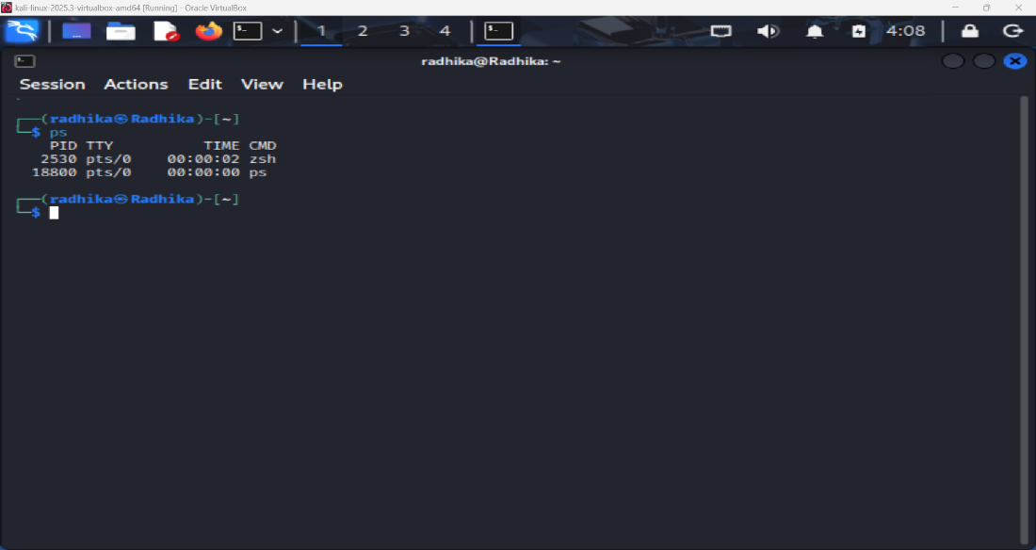

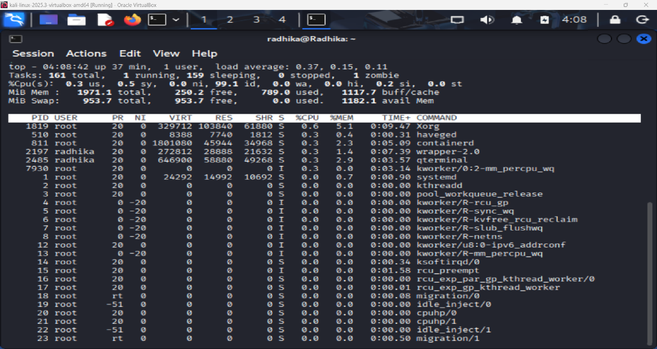
Figure 2: top
Figure 2

- Disable unnecessary services to reduce attack surface:
Every running service increases the system’s attack surface, meaning more potential entry points for attackers. Many operating systems enable services by default that may not be required by the user. Disabling unnecessary services reduces security risks and improves system performance. For example, stopping unused network services prevents attackers from exploiting vulnerabilities in those services. This proactive approach is a key part of system hardening and reflects good security hygiene.

- Documenting Best Operating System Hardening Practices:
Documenting OS hardening practices is an important step in maintaining long-term security. This documentation acts as a security checklist that outlines best practices such as updating the OS regularly, managing user permissions, enabling firewalls, disabling unused services, and monitoring logs. Proper documentation ensures consistency, helps during audits, and allows new administrators to follow established security standards. It also serves as evidence of security compliance and improves the organization’s overall security posture.
  - Regular Operating System Updates and Patch Management
One of the most important OS hardening practices is keeping the operating system updated. Regular updates and security patches fix known vulnerabilities that attackers could exploit. Documenting this practice ensures that updates are not ignored or delayed, helping the system remain protected against newly discovered threats.
  - Strong User Account Management
Proper documentation should include guidelines for creating, modifying, and deleting user accounts. This involves enforcing strong passwords, disabling inactive accounts, and ensuring that users have only one account where possible. Well-managed user accounts reduce the risk of unauthorized access and insider threats.
  - Implementation of the Least Privilege Principle
OS hardening documentation must clearly state that users should be given only the minimum permissions required to perform their tasks. By restricting access rights, even if a user account is compromised, the damage that an attacker can cause is significantly limited.
  - Secure File and Directory Permissions
File and directory permissions should be documented carefully to ensure that sensitive data is protected. This includes defining which users or groups can read, write, or execute specific files. Proper permission settings prevent accidental modification and unauthorized data access.
  - Disabling Unnecessary Services and Applications
The documentation should list services and applications that are not required and must be disabled. Removing unused services reduces the system’s attack surface and lowers the chance of exploitation through vulnerable or outdated services.
  - Use of Antivirus and Endpoint Protection Tools
Security documentation should specify the use of antivirus or endpoint protection software, along with update schedules and scan policies. This ensures that malware detection remains effective and up to date.
  - Backup and Recovery Planning
A strong hardening document always includes backup procedures. Regular backups and clearly defined recovery steps ensure that data can be restored quickly in case of system failure, ransomware attacks, or accidental deletion.

Conclusion:
Operating system is securely configured. Unauthorized access risks are minimized. System follows OS hardening best practices. Strong foundation for advanced cybersecurity tasks.

